|  |
| --- |
|  |
| User Manual of Online |
| For Coordinator |
|  |
| ©MetaShare Inc. |
| **8/4/2017** |

|  |
| --- |
| 本文包括Online的用户使用手册 |

**修订记录**

|  |  |  |
| --- | --- | --- |
| **日期** | **修改人** | **修改说明** |
| 2017-08-04 | 毕欣欣 | 初稿 |
|  |  |  |
|  |  |  |

目录

1 引言 1

1.1 目的 1

2 概述 1

3 运行环境 1

4 操作说明 1

4.1 登录 1

4.2 账户设置 3

4.3 个人信息 5

4.3.1 个人信息 5

4.3.2 联系信息 7

4.3.3 家庭信息 8

4.3.4 课外活动 12

4.3.5 学习成绩 13

4.3.6 标准考试成绩 15

4.3.7 推荐信 16

4.3.8 申请文书 17

4.3.9 升学目标 18

4.3.10 签证信息 24

4.3.11 人口信息 29

4.3.12 其他信息 29

# Overview

Coordinator schedule a product haul for a job through Online.

# Operations

## Rig Board

The Coordinator enters the system first into the Rig Board page. Also Coordinator can enter this page by click “Rig Board” in top menu of Page.

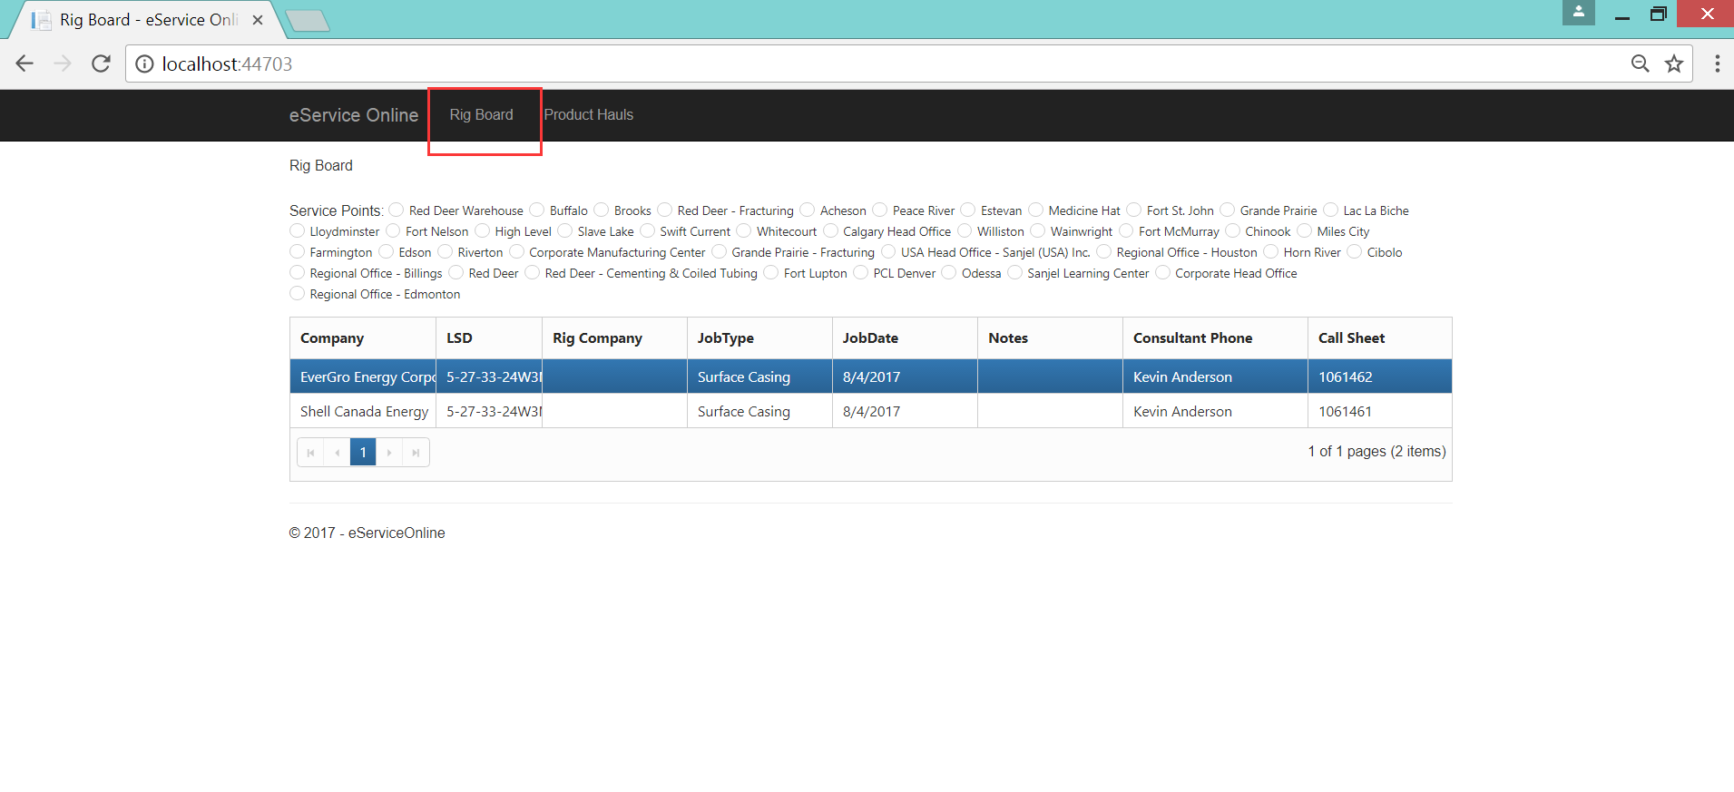

### Pop up Input page

The Coordinator right click a record in grid , pops up context menu. Click on “Haul Product” menu item pop up “Input Page”.

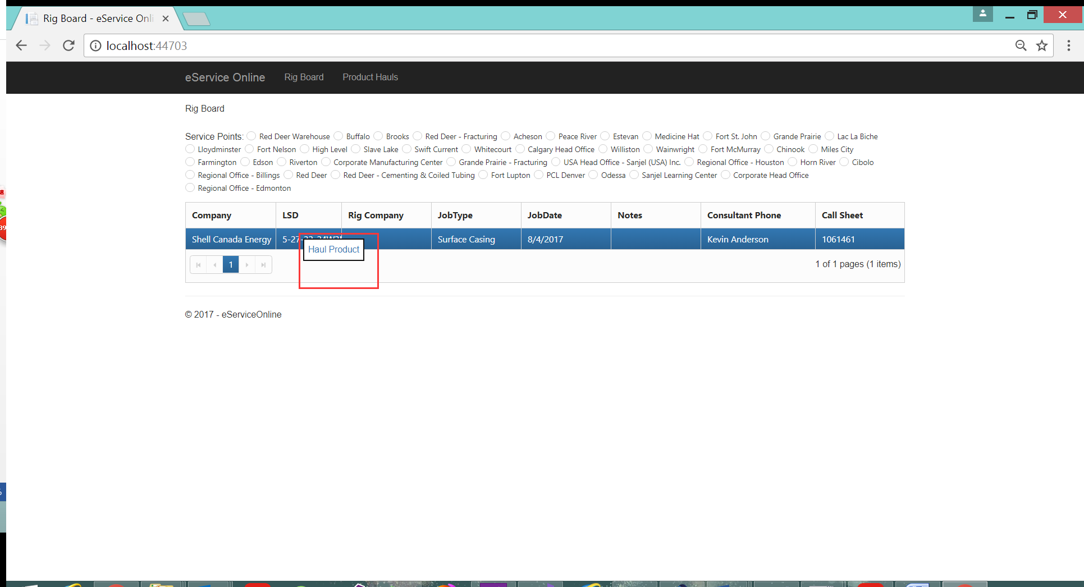

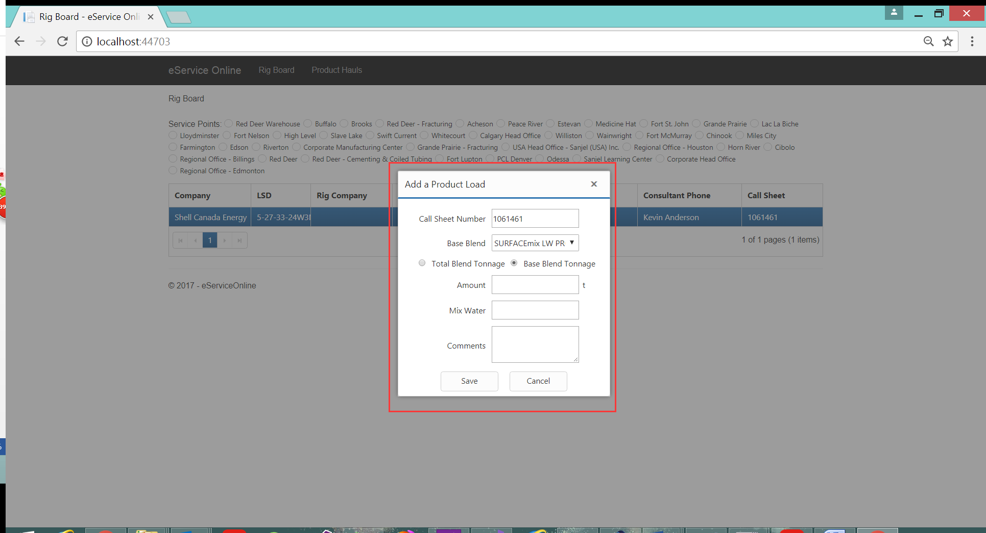

### Add a product load

Fill the Amount and Mix Water in Input page. Then click Save button .

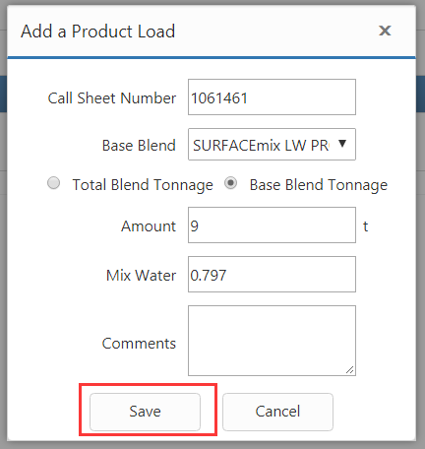

### Print load sheet

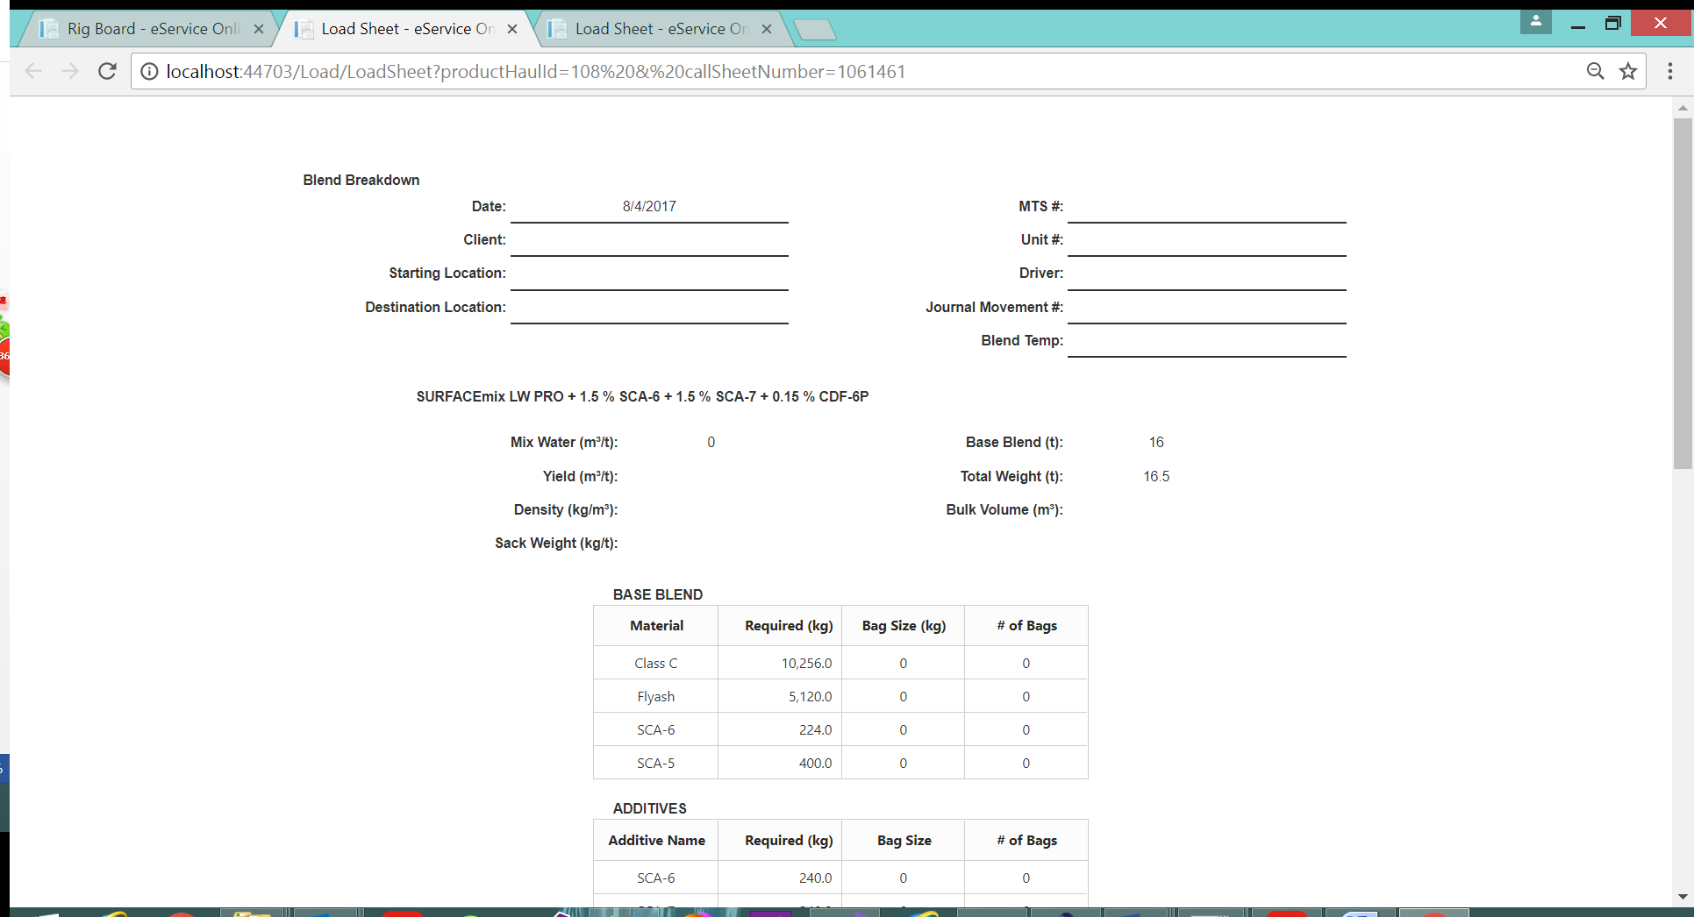

## Product Hauls Page

Also Coordinator enter this page by click “Product Haul” in top menu of Page.

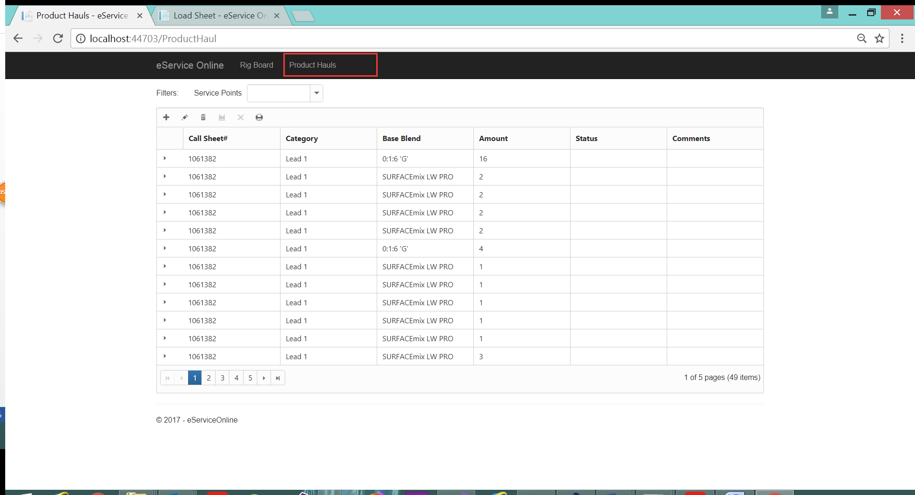

### View Product Haul List

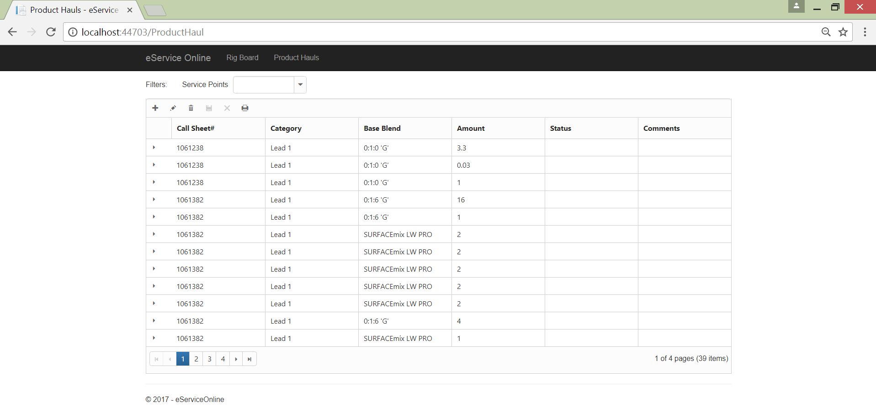

### Add a Product Load

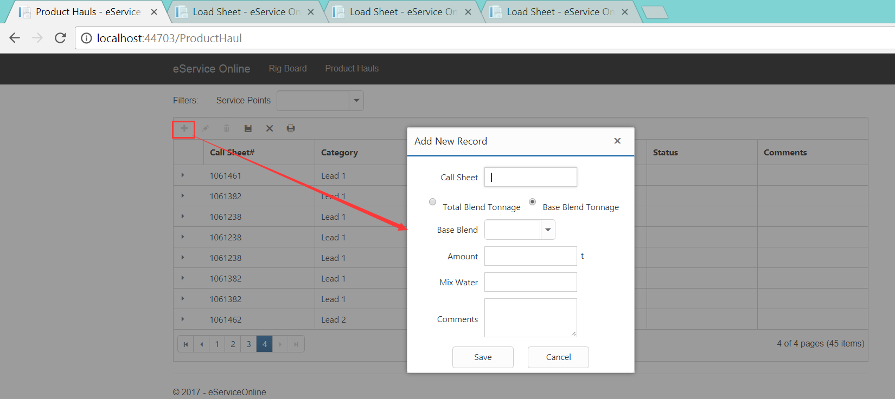

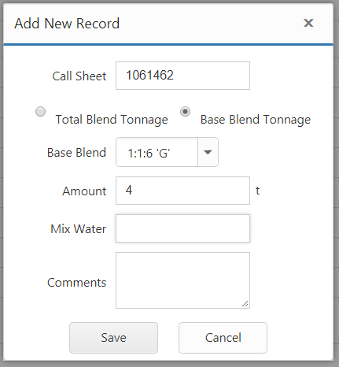

### Edit a Product Load

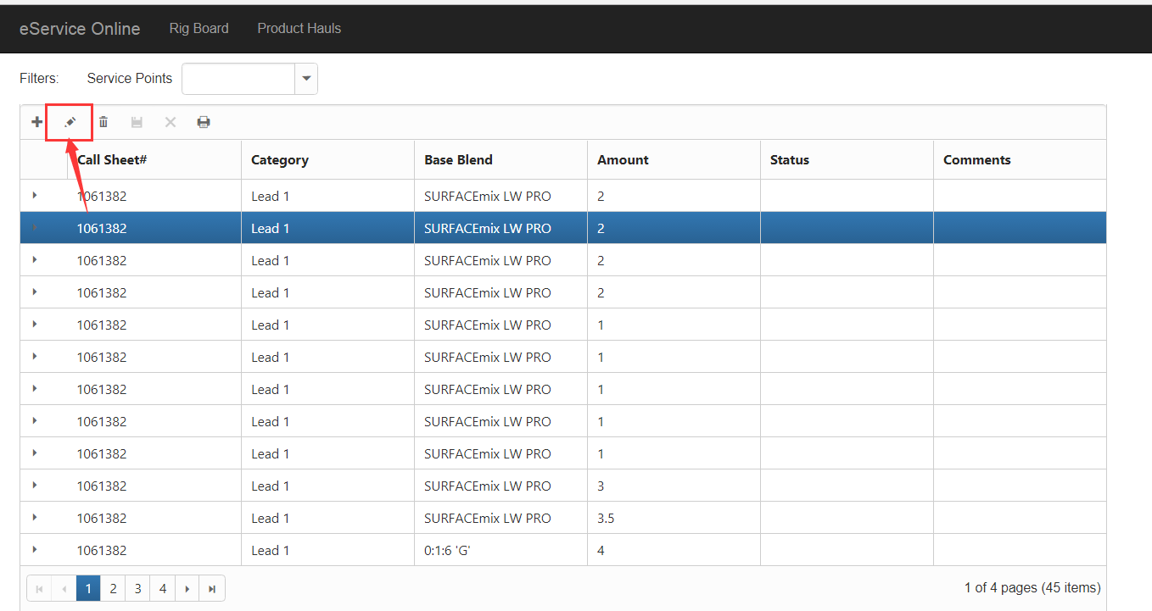

### Delete a Product Load

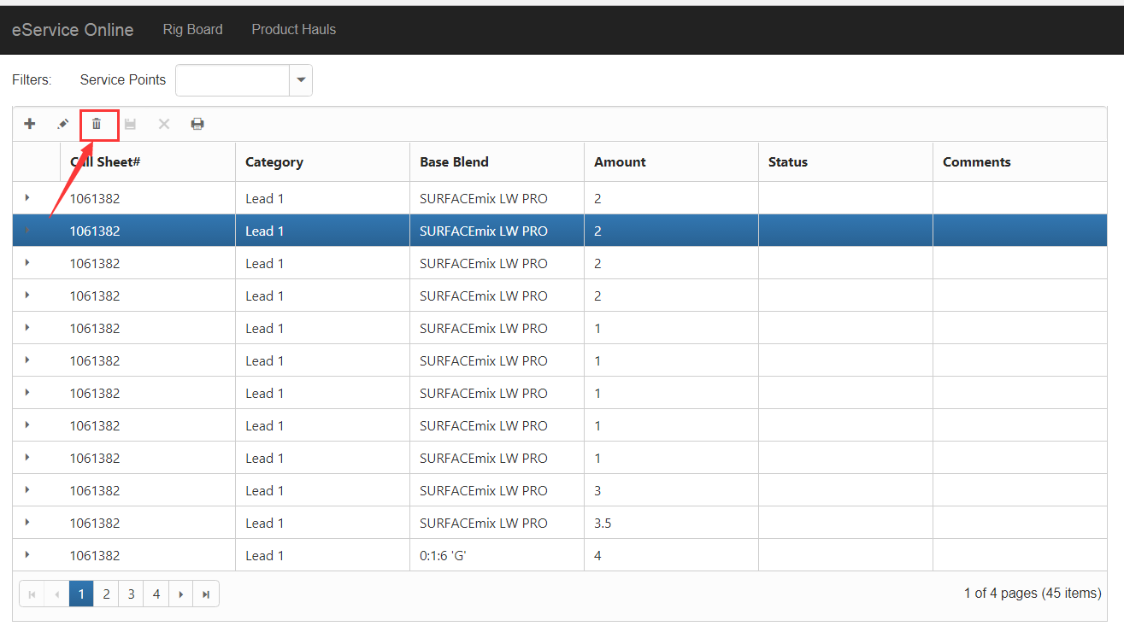

### Print Load Sheet

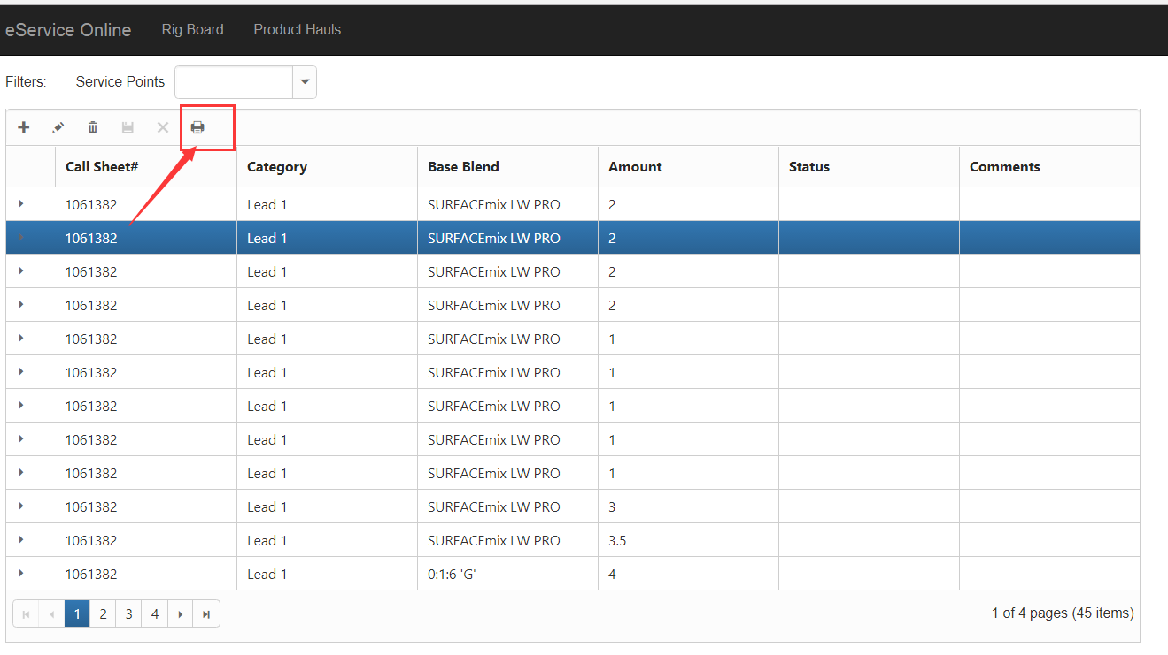

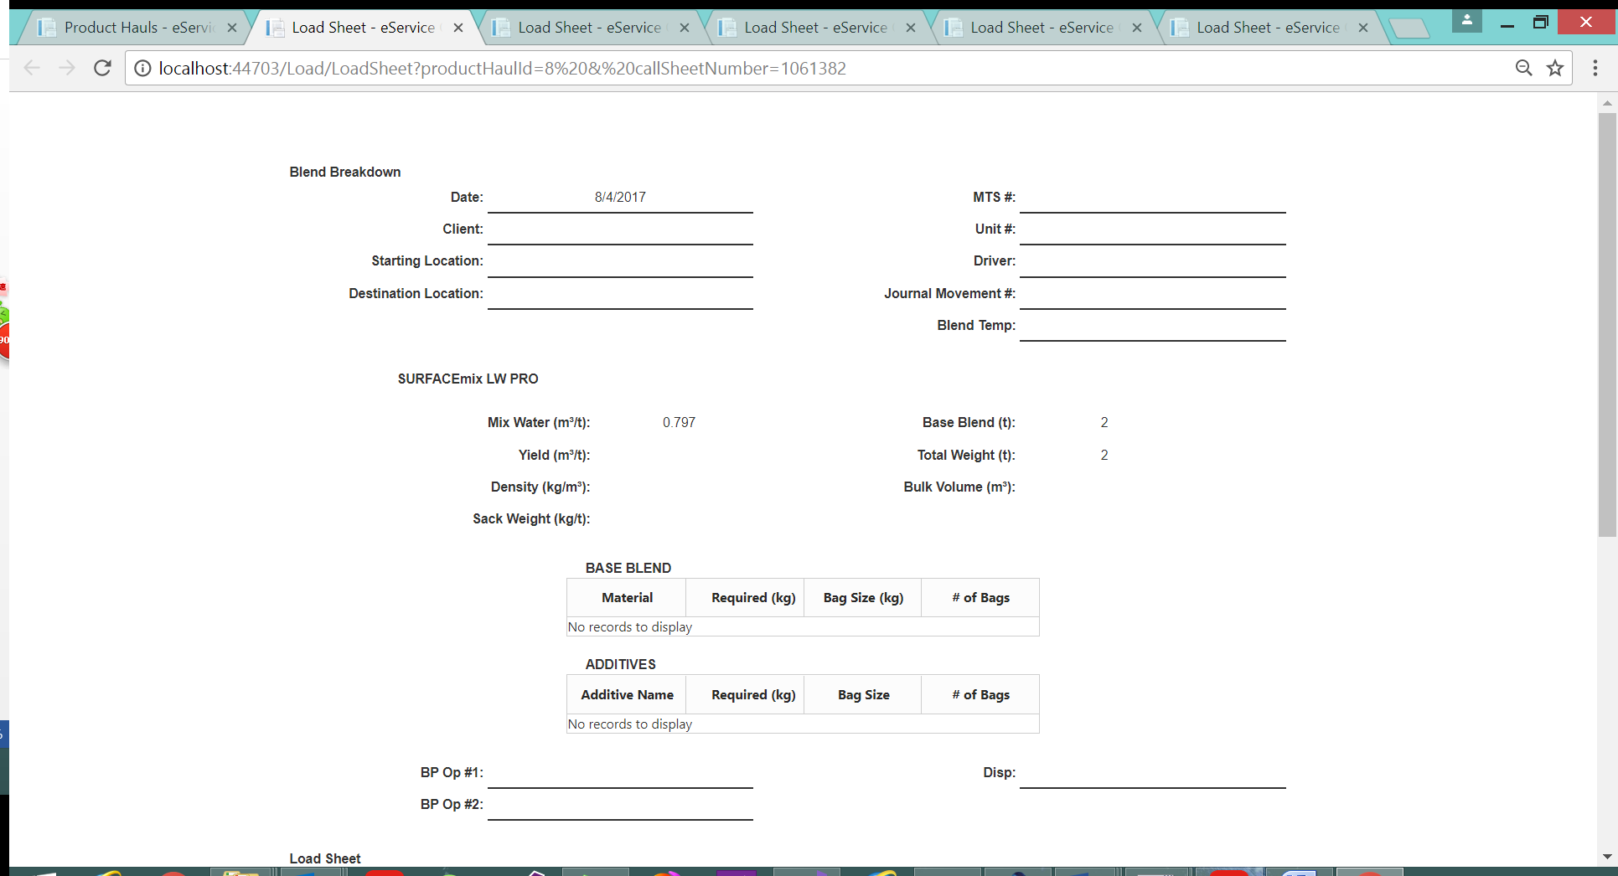

## Job Page

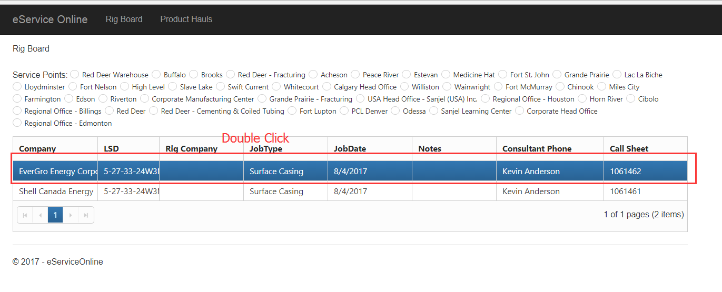

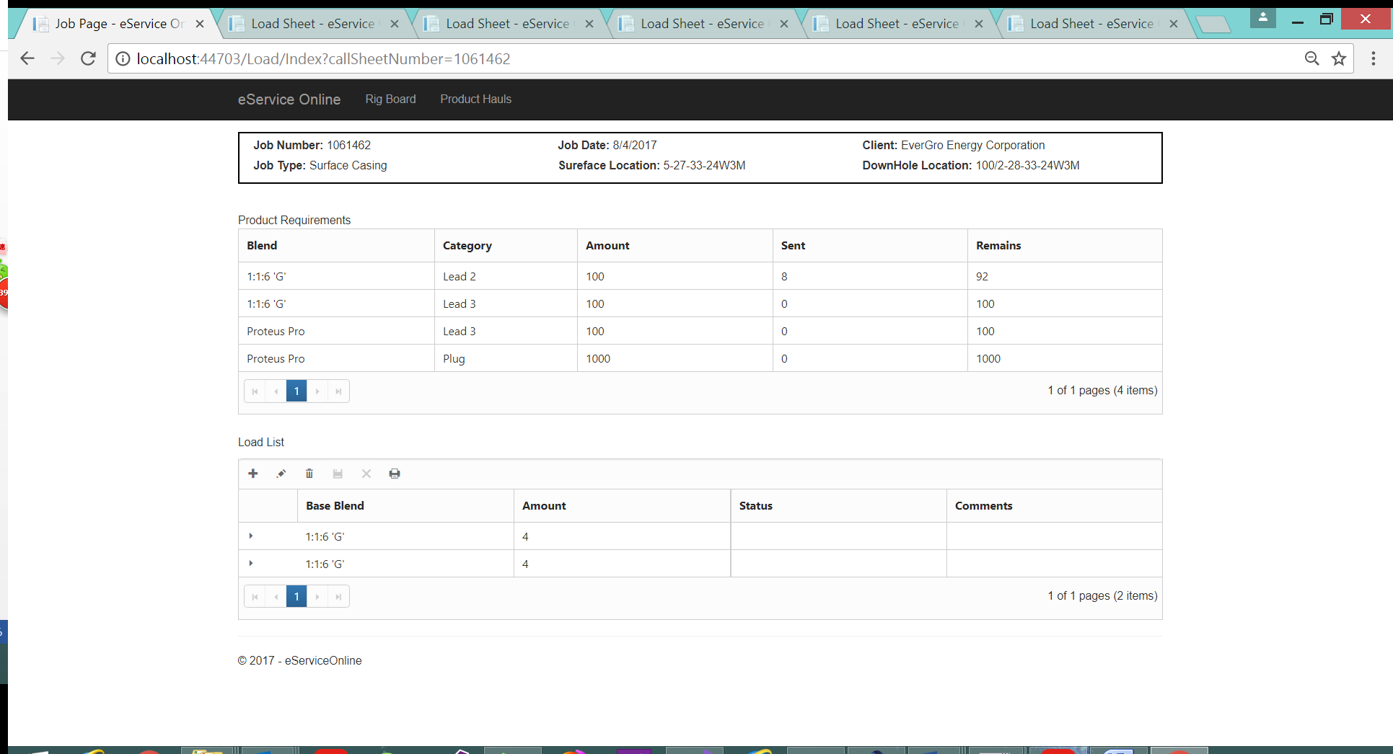

### Add a Product Haul

Same as 2.2.2

### Edit a Product Haul

Same as 2.2.3

### Delete a Product Haul

Same as 2.2.4

### Print Load Sheet

Same as 2.2.5